

**Department of Electrical and Computer Engineering**

project Report

**Project on ** 

Course  CSE311  

Section: 06   Semester

  spring 2020

Submitted to :  Nazmul Alam Diptu

**Group members **

abul kashim 

**Acknowledgement**

Firstly I express our heartiest thanks and gratefulness to almighty God for His divine blessing makes me possible to complete the Project.

We are really grateful and wish our profound indebtness to our honorable faculty Rifat Ahmed Hasan for his infinite patience, scholarly guidance, continual encouragement, constant and energetic supervision, constructive criticism and valuable advice

Also I would like to express our heartiest gratitude to our Lab Instructor Nazmul Alam Diptu to help us finish our project properly, providing us guideline and covering stuff that weren’t related to course but helped in our project enormously from his personal time.

**Abstract**

The purpose of the website is to raise Donations , and the people in need. Users signing up to this website will be able to donate their valuable money to a good cause. They will be able to receive money from the community full of donator’s as well.

Users must sign up with proper validation , and then they will be easily able to collect or distribute money between the community. With proper reasoning and proof Users will be able to request a donation. The donations and Posts will be tracked down and visible on the users profile to show his contribution ! Once a post meets donation requirements it will be automatically removed from the feed so that the feed isn’t flooded with old posts . Admin of the website will monitor all the activities of the website. They Hold all the power of the website, as they will be able to delete any post or user. They can specifically delete any user will all his post along it if found of suspicion by the admin. The user – admin communication is made , and users will be directly able to communicate with the admins through a contact page. None like this website exist in Bangladesh right now, and this concept would really help the people to get help, different NGO can take initiative to raise fund for a cause and reach them to the poor people to eradicate the poverty

The front-end development of the website was built with HTML5 , CSS3 and Bootstrap Library 4. The backend of the website was built with pure PHP language, no frameworks. The data of the users and Website was stored in a Relational Database Management System, MySQL.

**Table of Contents**

**CONTENT** **Page No**

Front 1

Acknowledgement 2

Abstract 3

Table of Content 4

Introduction 5

Resource 6

Background Study 7

## Methodology

Entity Relationship Diagram 8

Front End Development 10

Back End Development 11

Webpage details 12

Conclusion and Future Work 19

Introduction

charitable: Donate for covid19 sufferers website is a Modern web to help the people that are in distress, Plenty of people are eager to donate as there is high reward according to Islam, some people do it to get Jannat while others do it for Humanity.

CharitAble : donate for covid19 sufferers built for serve the platform, whatever the reason behind it people will be able to donate their money to the people in need. Now- a-days a lot fo people become jobless due to covid19 pendemic , someone close falls sick severely and requires a high amount of money for treatment, as we see a lot of campaigns these days over facebook asking for donations. But facebook isn’t the best platform for this and doesn’t provide the support for this yet as people don’t see just donation requests and it might get missed by a person who wants to donate but was unaware of it. For this **Charitable: Donate for covid19 sufferers** comes to serve the purpose, collecting all the donation requirements where donators will be able to find and search through the posts to donate to whatever cause they like this will be helpful for both the persons. The person who needs the money and also for the person who wants to donate the money.

Users can view posts without signing into it and Contact the admin if they find any issue regarding the website. These messages will be automatically sent to the admins of the website and they can together solve these issues.

As a User people will be able to post and ask for donations by specifying the amount of donation they require and also donate to other people. This might be for the user himself or for his friend or near and dear ones. People can donate and fulfill a persons wish for studying in college or for a life saving surgery. CharitAble will be a place where people will be able to help eachother by the act of humanity. Admins will monitor its fraudulent.

Resources

# FRONT END

* HTML 5
* CSS3
* Bootstrap Library

# Back End

* PHP
* MySQL

# Code Editors

* notepad++
* Extensions
  + - 1. HTML CSS Support
      2. IntelliSense for CSS class
      3. PHP Server

# Server

* Xampp
* PHP Server VS CODE

# Browser

* Google Chrome

Background Study

The preliminary purpose of raising money for covid-19 sufferers website is to help people . The idea was taken from a very popular website Gofundme.com

But sadly GoFundMe is not available in Bangladesh , as due to payment procedures. International Payment processes like Paypal , Payoneer isn’t available in Bangladesh yet, this is yet another reason for websites like Amazon not being available here.

This website might not solve the payment problem but it can provide a proxy environment for the people of Bangladesh. To help raise funds with the help of a concept called Crowd Funding.

What basically Gofundme does is they let a user start a campaign and let them describe their story , and then share it with the crowd. Then the interested people are able to donate in the cause! And the users receive the donations.

CharitAble is same in this concept and procedure. The users will be able to start a campaign (Create a post) and ask for donation, and other users of the community will be able to donate to it if they want. All the donations are tracked and the process is Fast, free and safe. They both serve to raise funds without any platform fee, funds are directly transferred from the donator to the donee. This way of raising funds would be Crowdfunding as Crowdfunding harnesses the power of social networks and the internet to give people the means to raise funds, help others overcome hardship, and meet aspirational gols. With crowdfunding , you can help a friend or help an entire community. You can do everything from pay for your own surgery to fulfill a student’s dream of attending college- and so much more

Methodology

Keeping the concepts of the website and the required functionalities an ER – Diagram of the website was constructed to get the abstract idea of the total data management of the website.

# Entity Relationship Diagram

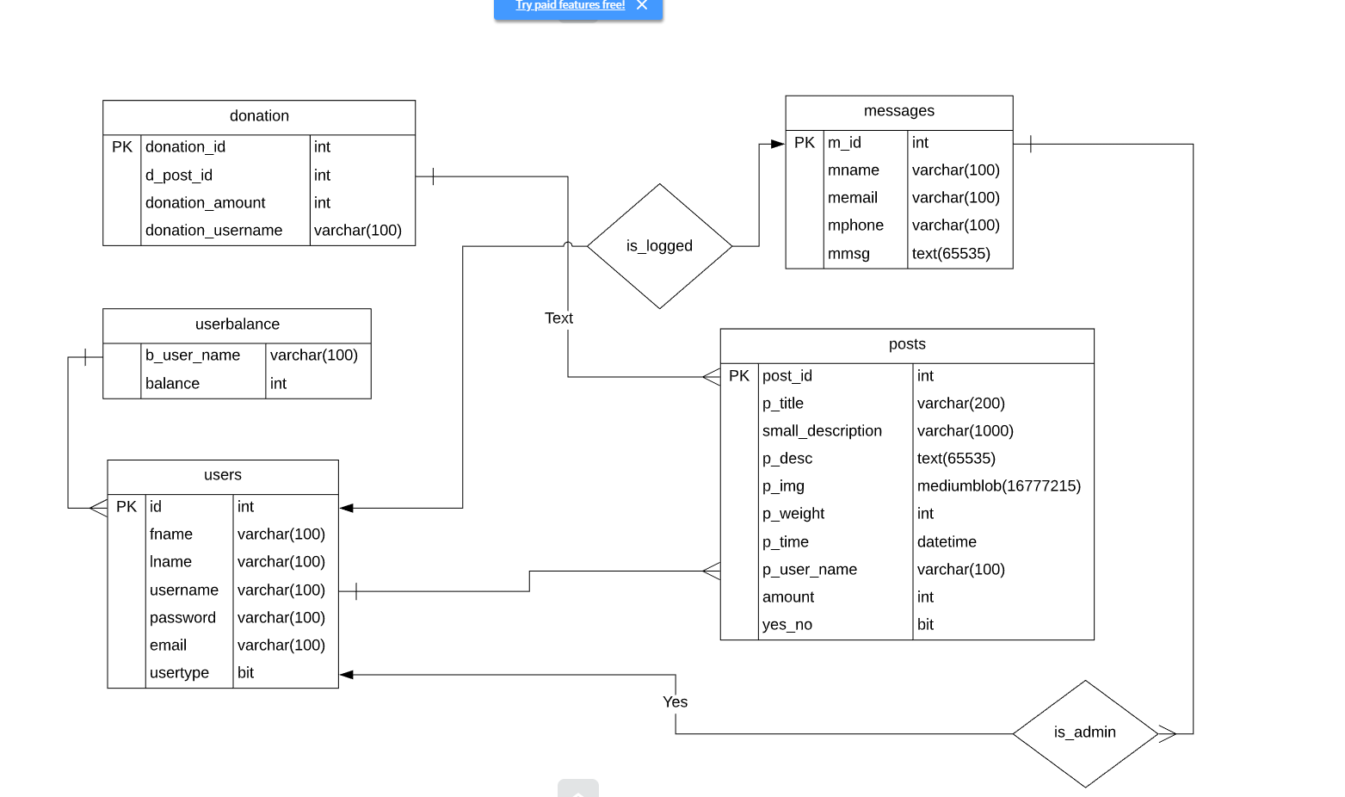

Fig : Entity Relationship Diagram

Users

The user entity contains all the required information for the user, uniquely defined by id. The other attributes consist of First Name , Last Name , username, email and usertype. The usertype attribute is used to determine if the user is a admin or not.

Messages

Messages are differentiated using a special autogenerated message id , other than that the attributes are name, email, phone and message out of this phone can be optional, contain null values. But emails and Names are essential for later contact by admin

posts

Posts unique key is post_id and posts must contain Title, Small description , Description and target amount. Image is optional. Post weight is updated based on the times the post has been viewed and yes_no indicates the status of the post if it has been raised yet or no.

donation

Donations are tracked using a donation it, it connects the user and post. The person it is being donated to and the person donating it, and the amount. It further helps to show the history of donation in a users profile.

userbalance

Userbalance currently holds the money , it has been made for future development where options to withdrew money and add money as credit and donate from the credit will be implemented.

The relationships between the Entity’s are shown in the figure.

# 

# Front End

Front End development was done with HTML5, CSS3 and Bootstrap4

The basic structure of the posts were given with HTML and CSS , and few templates from Bootstrap were used to make the website have a materialistic design look.

Example of HTML :

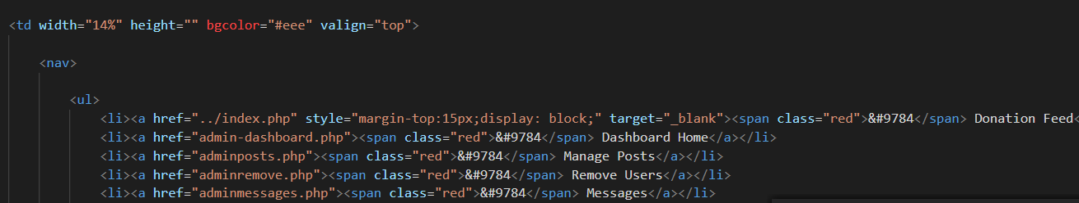

Tables , unordered lists, headers and paragraphs were used along with all the basic and intermediate html tag tools.

Example of CSS

CSS targetting Div tags, attributes and ids were used to make the HTML much prettier

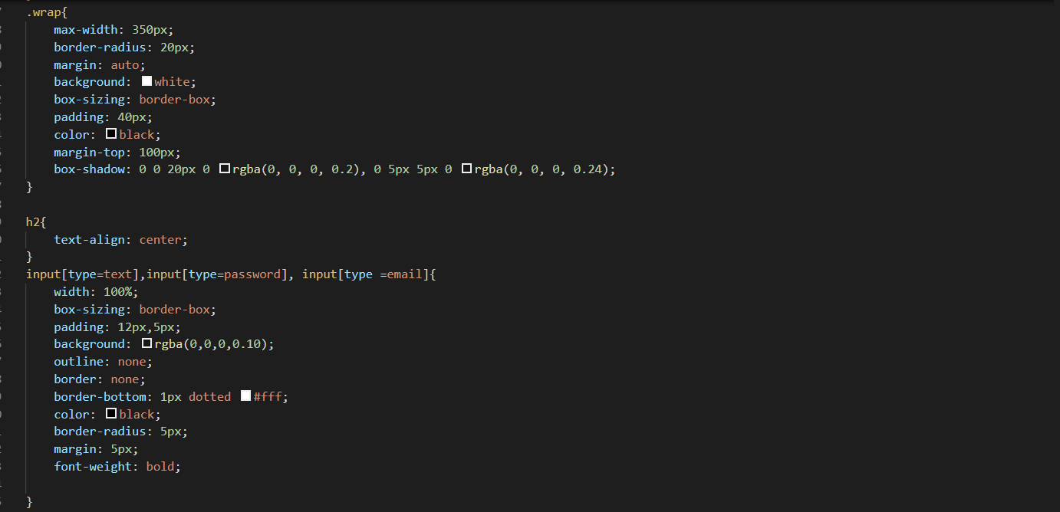

Example of Bootstrap4

Bootstrap predefined columns and Buttons were used to have an easier formatting of the webpages, not all pages contained bootstrap . Bootstrap templates were used in Index, Contact and About pages mainly.

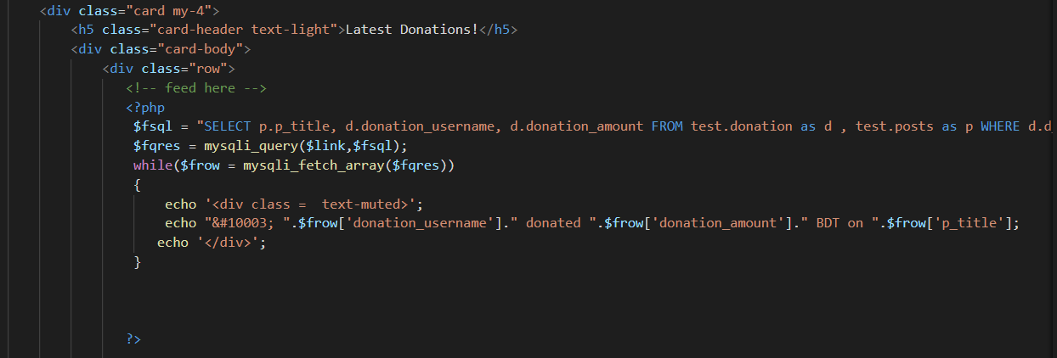

# Back End

Backend development of the website was done with php. No frameworks were used as per guideline of Lab Instructor.

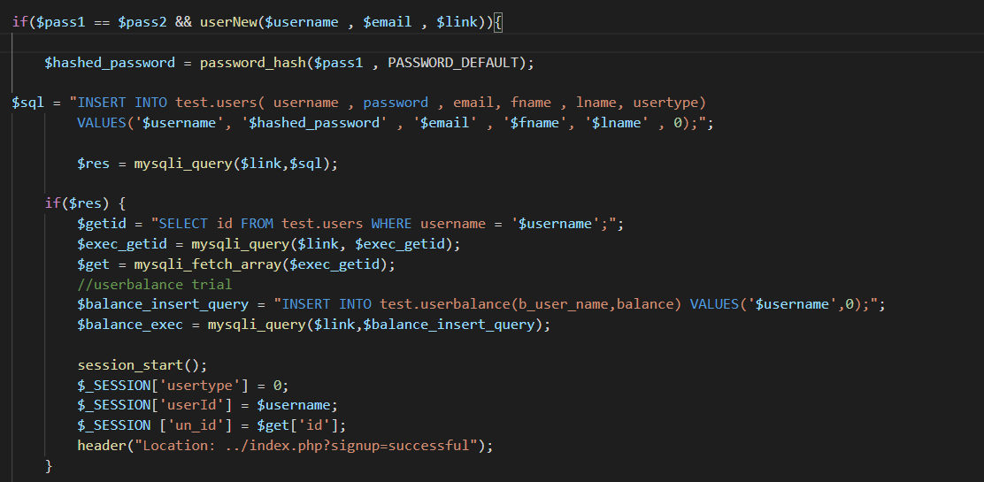

# Webpage details

Githublink:<https://github.com/kashimmirza/cse311project>

Conclusion and Future Scope

# Conclusion

Conclusion and future scope

# conclusion:

The current work is the initial background report for the website development project. This report aims to provide a critical review of the relevant literature in the webfield and the data management system. To design an optimal database and complete the three anomalys. So there are no redundant data for the website in the database. Doing it with a website helps to gain practical knowledge , this report is to show the practical knowledge gained and the functionalities of the project. How to write the proper queries and extract the data, and how to process the extracted data inside your work. Getting hand in hand with powerful back end language like php. Mastering the database design and handling data from the database, taking data of users and processing it with the help of a strong database.

The website has been made with opportunities to donate and ask for donations. As such website doesn’t exist in Bangladesh the community can come together and help the people in distress very much. This crowd funding process would save thousands of lives. The website would be a place for the rich and elite society who wants to donate, the good hearted people could just come here and donate to the emerging problems like covid19 pendemic of Bangladesh . Not just personal problems. Rohingya Crisis, Fires and even Natural calamities campaign can be held here and the users will be able to donate here.

The admins will monitor the website, multiple admins can moderate at a time and the admins will be able to remove fraud posts from the users.

# Future Scope

Charitable: donate for covid19 sufferers website is incomplete , as this project was given on a learning curve of three month time, there is a lot of room to improve on this project the future scopes of this projects would be developing proper feature to add credit and make the donation system realistic Options to withdrew credit from the account . As money is involved adding more security to the data transfer of the website and the security of the database. More optimal database to remove redundancy that still might exist.

Also the website doesn’t update real-time the realtime search, and update of posts can be implemented in the future, using API’s to take the log in feature, from google or facebook can be also implemented so that users have a more easier way to sign up for the website.